Cynomolgus IL-23A & Human IL-12B Heterodimer Protein; His Tag

Product Information
Product Name | Cynomolgus IL-23A & Human IL-12B Heterodimer Protein; His Tag
Storage temp. | Store at ≤ -70℃, stable for 6 months after receipt.  Recommend to aliquot the protein into smaller quantities for  optimal storage. Please minimize freeze-thaw cycles.
Catalog# / Size | GM-88027RP-100 / 100 μg
 | GM-88027RP-1000 / 1 mg

Protein Information
Alternative Names | IL-23 alpha & IL-12 beta Heterodimer
Source | Cynomolgus IL-23A & Human IL-12B Heterodimer Protein; His Tag (GM-88027RP) is expressed from human 293 cells (HEK-293). It contains AA(Cynomolgus IL-23A) Val 22 - Pro 189 (Accession # G7PIH8) and AA(Human IL-12B) Ile 23 - Ser 328 (Accession # P29460-1).  This protein carries a His tag at the C-terminus of Human IL-12B.
Purity | > 90% as determined by SDS-PAGE
Endotoxin | < 1 EU/μg, determined by LAL gel clotting assay
Predicted Mol Mass | 18.5 KDa (IL-23A) and 34.4 KDa (IL-12B)
Formulation | Supplied as a 0.2 μm filtered solution of PBS, pH7.2-7.4.
Description | IL-23 is a heterodimeric cytokine made of IL-23 alpha (p19) and IL-12 beta (p40) subunits. While p40 is shared with IL-12, p19 is unique to IL-23. It binds to its receptor complex (IL-23R and IL-12Rβ1) to regulate Th17 cells, promoting the release of pro-inflammatory cytokines like IL-17 and IL-22, driving immune inflammation.  IL-23 plays a significant role in many inflammatory and autoimmune diseases, such as psoriasis, Crohn's disease, ulcerative colitis, and rheumatoid arthritis. Due to its regulation of Th17 cells and inflammatory responses, IL-23 has become an important therapeutic target. Drugs that specifically block p19 (e.g., guselkumab) have been used to treat various inflammatory diseases. Additionally, p40-targeting drugs (e.g., ustekinumab) can inhibit the functions of both IL-12 and IL-23, thereby alleviating disease progression.

SDS-PAGE
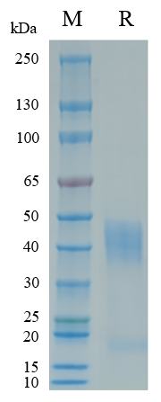
On SDS-PAGE under reducing (R) condition. The gel was stained overnight with Coomassie Blue. The purity of the protein is greater than 90%.

Bioactivity-ELISA
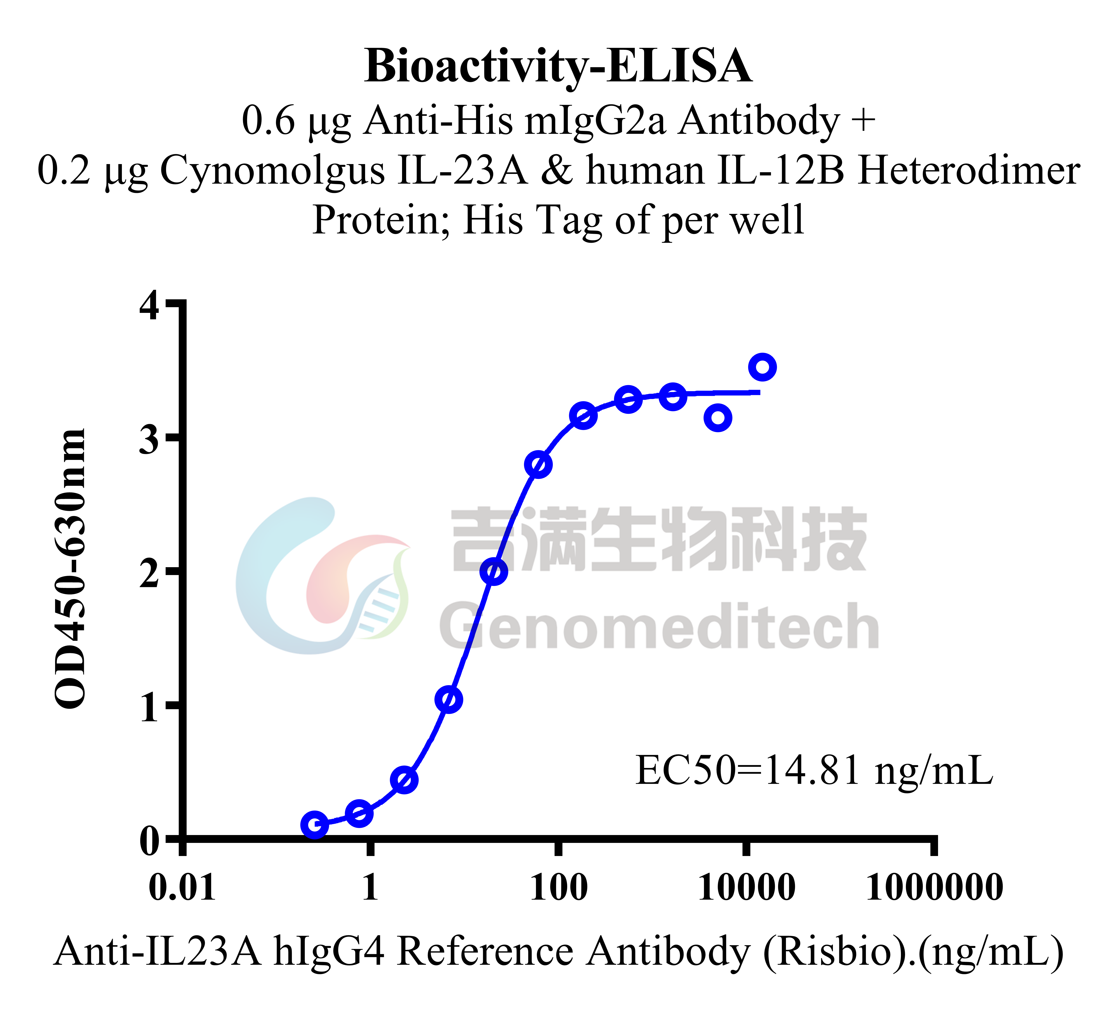 | 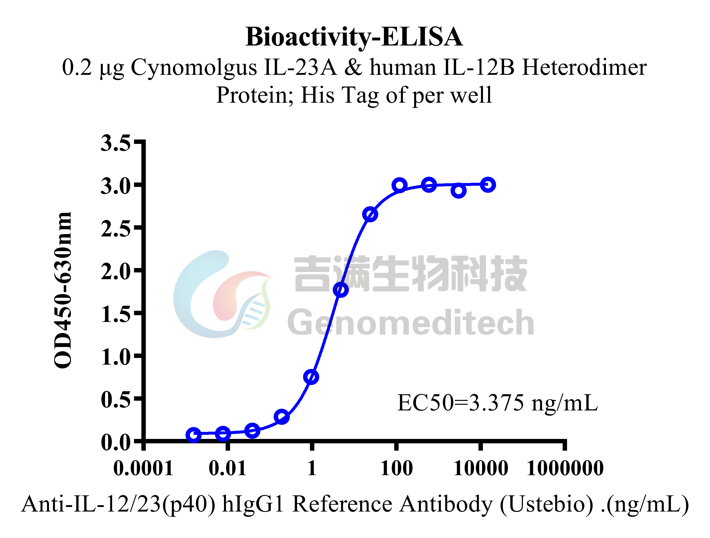
Cynomolgus IL-23A & Human IL-12B Heterodimer Protein; His Tag (Catalog # GM-88027RP) was immobilized at 2 μg/ml (100 μL/well) on Anti-His mIgG2a Antibody (Catalog # GM-59493AB) (0.6 μg/well) precoated. Increasing concentrations of Anti-IL23A hIgG4 Reference Antibody (Risbio) (Catalog # GM-88013MAB) were added. | Cynomolgus IL-23A & Human IL-12B Heterodimer Protein; His Tag (Catalog # GM-88027RP) was immobilized at 2 μg/ml (100 μL/well). Increasing concentrations of Anti-IL-12/23(p40) hIgG1 Reference Antibody (Ustebio) (Catalog # GM-87870MAB) were added.

Bioactivity CELL BASE
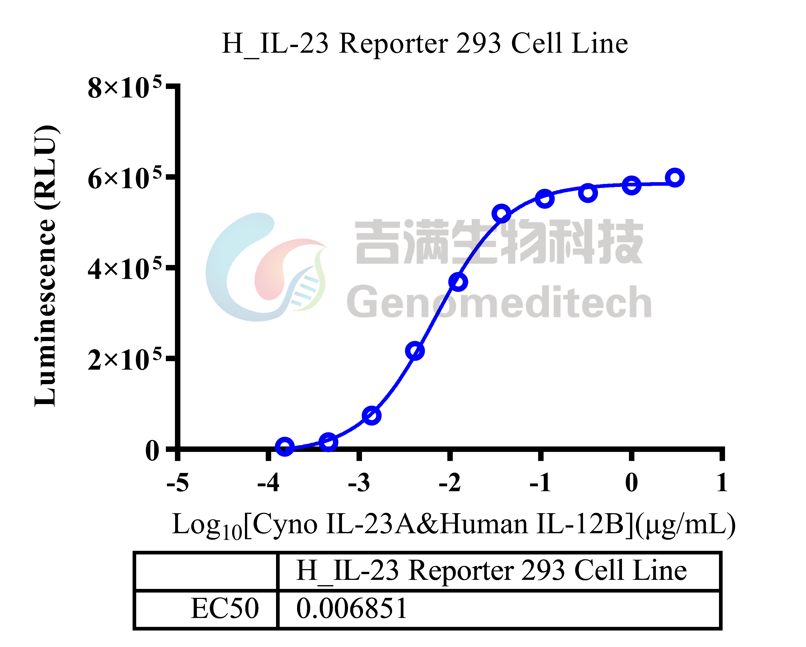
Cynomolgus IL-23A & Human IL-12B Heterodimer Protein; His Tag (Catalog # GM-88027RP) was added into H_IL-23 Reporter 293 Cell Line (Catalog # GM-C06722), and then IL-23/IL-23R signals were stimulated.

